Working Functionalities of EHS
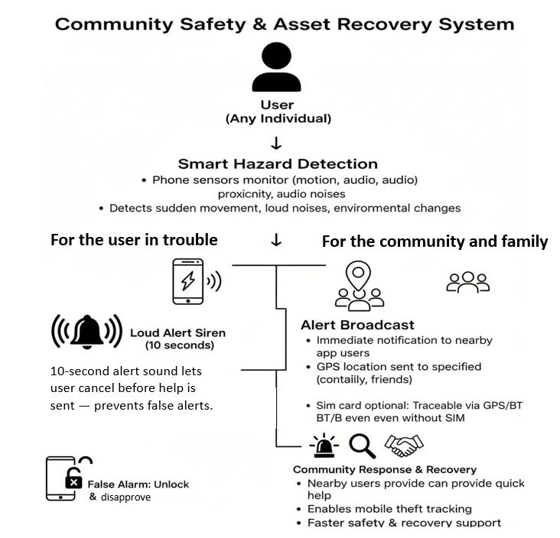

Fig 1: Complete idea of the app

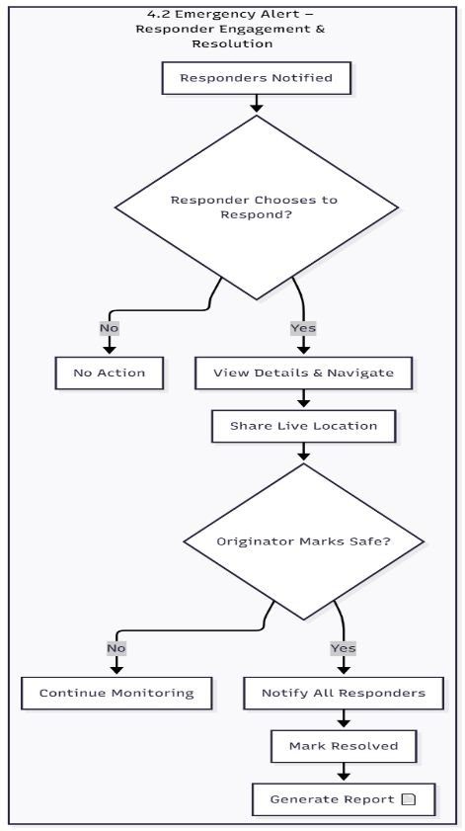
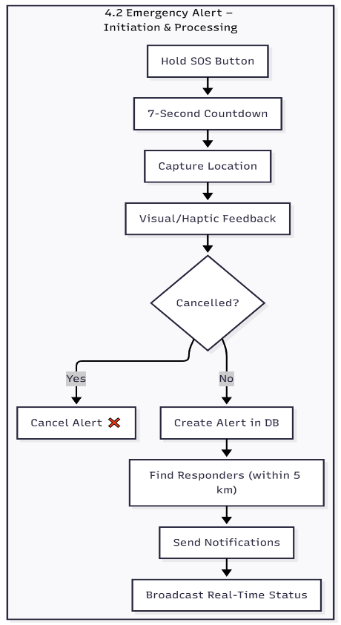
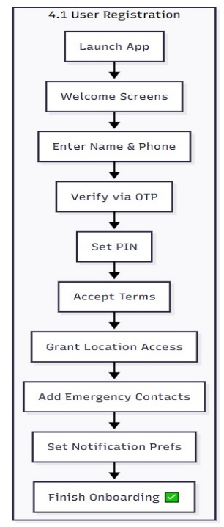

Fig 2: Working of the manual SOS button

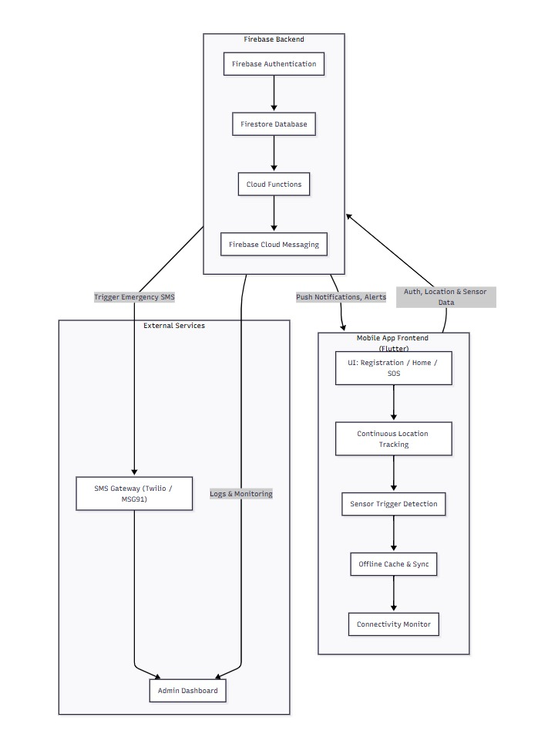
Fig 3 : Frontend and Backend connection of the
app

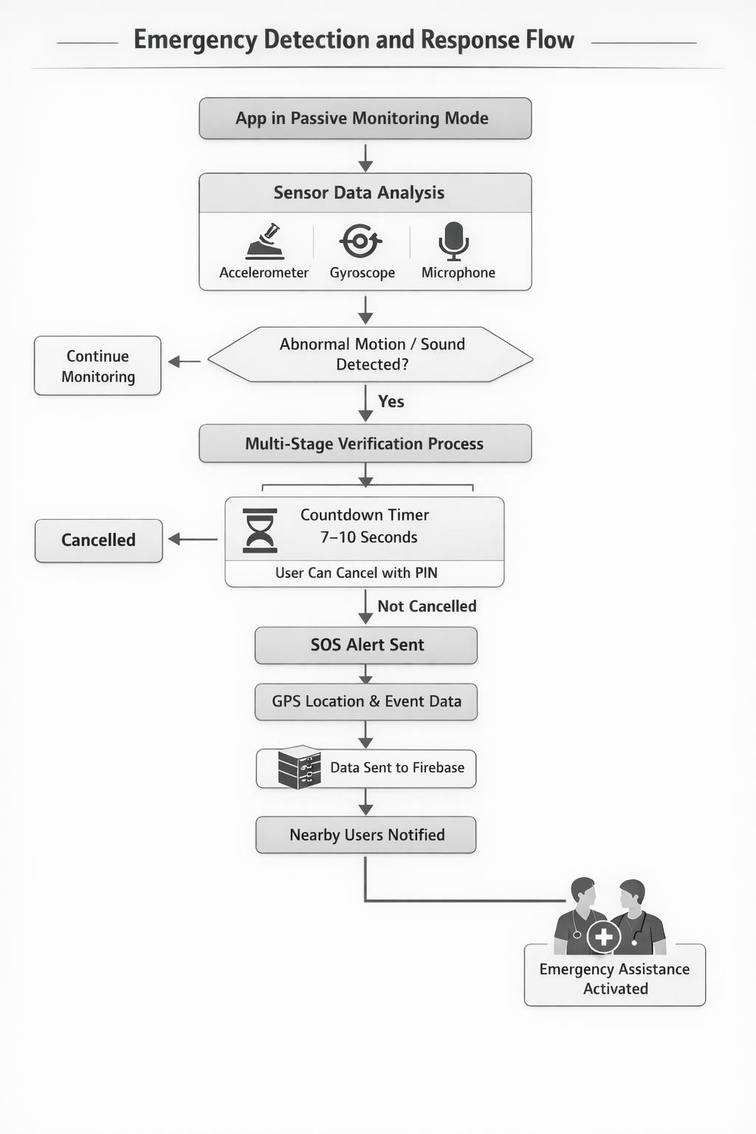

Fig 4: Working flow of the sensor integration
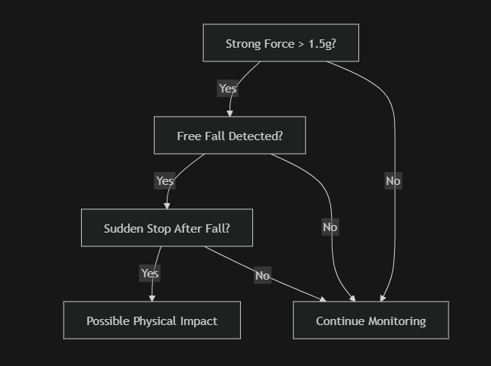
X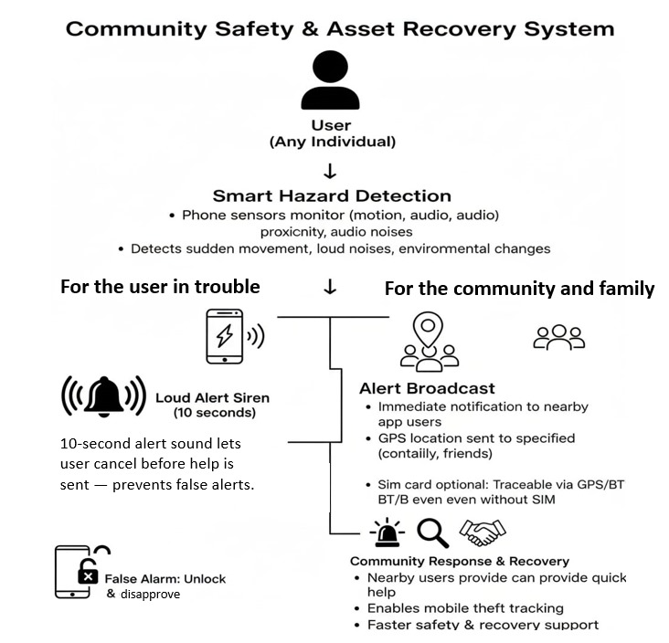

Fig 5 : Working of the accelerometer sensor

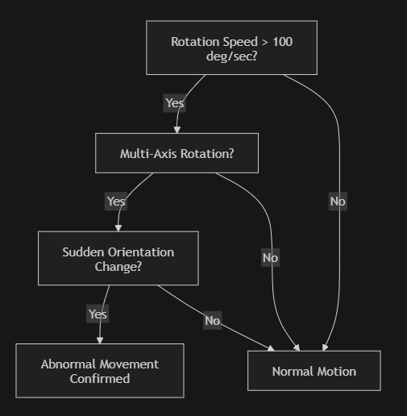
X
X

Fig 6: Working of the gyroscope sensor

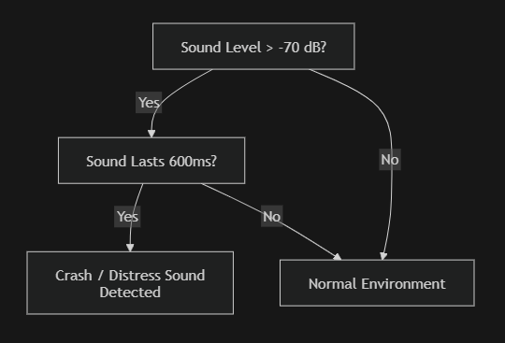
Y
X

Fig 7: Working of microphone sensor

